# 3.6 The Cross Product: Algebra

## THE CROSS PRODUCT OF TWO VECTORS

A vector that is perpendicular to both vectors $\vec{u}=\left\langle u_{x},\left.u_{y}\right\rangle \right.$ and $\vec{v}=\left\langle v_{x},\left.v_{y}\right\rangle \right.$, can be found using the cross product. The cross product requires that both vectors be in three-dimensional space.

The cross product of vectors $\vec{u}=\left\langle u_{x},\left.u_{y}, u_{z}\right\rangle \right.$ and $\vec{v}=\left\langle v_{x},\left.v_{y}, v_{z}\right\rangle \right.$ is a vector and is defined to be

$$\vec{u}×\vec{v}=\left\langle u_{y}v_{z}- u_{z}v_{y}, { u}_{z}v_{x}-u_{x}v_{z}, \right.\left.{{ u}_{x}v}_{y}- u_{y}v_{z}\right\rangle$$

This formula is challenging to remember. A nice device to help you remember both this formula and the dot product formula is to visualize them in a 3x3 square of components. The square shows how vectors can interact with one another.

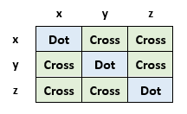

For the cross product,

The $x$-component has a product that involves no $x$-components: ${ u}_{y}v_{z}- u_{z}v_{y}$

The $y$-component has a product that involves no $y$-components: ${ u}_{z}v_{x}-u_{x}v_{z}$

The $z$-component has a product that involves no $z$-components: ${{ u}_{x}v}_{y}- u_{y}v_{z}$

Each component is a difference of two diagonal products.

|  |  |
| --- | --- |
| Table showing a 3x3 square of components with examples of cross products. | To produce the $x$-component,  (top right) - (bottom left) = y*z – z*y  To produce the $y$-component,  (bottom left) - (top right) = z*x – x*z  To produce the $z$-component,  (top right) – (bottom left) = x*y – y*x |

The **DOT** product is the interaction between two vectors having **similar** components: $$x∙x, y∙y, z∙z$$

The dot product measures similarity since it combines only interactions of matching components.

The **CROSS** product is the interaction between two vectors having **different** components:

$x ∙y, x∙z, y∙x, y∙z, z∙x, z∙y$

The cross product measures cross interactions since it combines interactions of different components.

Find the cross product of the vectors $\vec{u}=\left\langle 5,\left.2, 4\right\rangle \right.$ and $\vec{v}=\left\langle 3,\left.4, -7\right\rangle \right.$.

Example (1)

|  |  |
| --- | --- |
| 3x3 square table of components with calculations for finding a cross product of the two vectors. | 3x3 square table of components with results of a cross product of the two vectors. |

To produce the $x$-component, (top right) - (bottom left) = 2*(-7) – 4*4 = -30

To produce the $y$-component, (bottom left) - (top right) = 4*3 – 5*(-7) = 47

To produce the $z$-component, (top right) – (bottom left) = 5*4 – 2*3 = 14

$$\vec{u}×\vec{v}=\left\langle -30, 47, \left.14\right\rangle \right.$$

*Be careful with the computation. It goes (bottom left) – (top right) while  
the first and last go (top right) – (bottom left).

## USING TECHNOLOGY

We can use technology to find the cross product between two vectors.

Go to www.wolframalpha.com.

To find the cross product of the vectors $\vec{u}=\left\langle 5,\left.2, 4\right\rangle \right.$ and $\vec{v}=\left\langle 3,\left.4, -7\right\rangle \right.,$ use either the “cross” or the x command. Wolframalpha tells you what it thinks you entered, then it tells you its answer. In this case, $\vec{u}×\vec{v}=\left\langle -30, 47, \left.14\right\rangle \right.$.

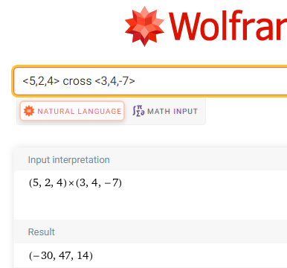

## THE RIGHT-HAND RULE

You can see that the cross product of the two vectors $\vec{u}$ and $\vec{v}$, is itself a vector. But where is this vector $\vec{u}×\vec{v}?$ The cross product of two vectors is a vector that is perpendicular to the plane formed by the two vectors. What about the two perpendicular directions? Does this perpendicular vector lie above or below the plane formed by the two vectors? We use the **right-hand rule**.

Hold your hand as shown in the picture, your index and middle fingers extended. Your thumb points in the direction of the cross product.

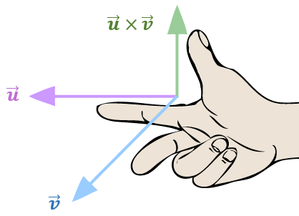

Since the dot product is a scalar, it follows the properties of real numbers.

**PROPERTIES OF THE CROSS PRODUCT**

1. $\vec{u}×\vec{v}=-\vec{v}×\vec{u}$, the cross product is **anti-commutative**
2. $\vec{u}×\left(\vec{v}+\vec{w}\right)=\vec{u}×\vec{v} + \vec{u}×\vec{w}$, the cross product distributes over vector addition
3. $k\left(\vec{u}×\vec{v}\right)=\left(k\vec{u}\right)×\vec{v}$ = $\vec{u}× \left(k\vec{u}\right)$
4. $\vec{u}×\vec{0}=\vec{0}$, the cross product with the zero vector, $\vec{0},$ is the zero vector, $\vec{0}$

## USING TECHNOLOGY

For example, use WolframAlpha to compute both the cross product $\vec{u}×\vec{v}$ and $\vec{v}×\vec{u}$, where

$\vec{u}=\left\langle 5,\left.-2, -3\right\rangle \right.$, and $\vec{v}=\left\langle 6,\left.4, 1\right\rangle \right.$ to show one is the opposite of the other.

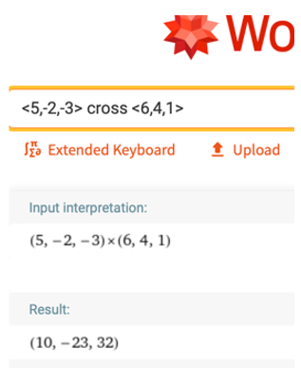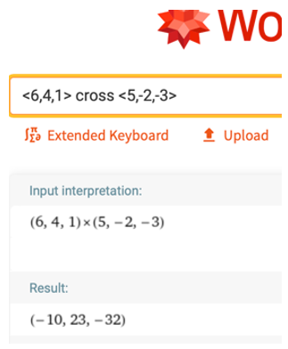

Notice that $\left\langle 10,\left.-23,-32\right\rangle \right.= -\left\langle -10,\left.23, -32\right\rangle \right.$, verifying property 1.

## EXAMPLES

1. Find the cross product of the vectors $\vec{u}=\left.⟨4, -2, 1\right\rangle$ and $\vec{v}=\left\langle 5,\left.-1, 3\right\rangle \right.$.

ANS: $\vec{u}×\vec{v}= \left\langle -5,\left.-7, 6\right\rangle \right.$

1. Find the cross product of the vectors $\vec{u}=\left.⟨-2, 3,-9\right\rangle$ and $\vec{v}=\left\langle -8,\left. 12, -36\right\rangle \right.$.

ANS: $\vec{u}×\vec{v}=\vec{0}$

1. Find $\vec{u}×\vec{v}∙\vec{w}$, where $\vec{u}=\left\langle -2,\left.5, 3\right\rangle \right.$, $\vec{v}=\left\langle 4,\left.4, -2\right\rangle \right.$, and $\vec{w}=\left\langle 2,\left.6, -5\right\rangle \right.$.

ANS: $144$

* Note that the cross product must be computed first since if it is not, we would be crossing a vector with a scalar.

## NOTE TO INSTRUCTOR

Consider demonstrating these examples.

1. Find the cross product of the vectors $\vec{u}=\left.⟨5, -2, 6\right\rangle$ and $\vec{v}=\left\langle 2,\left.-1, 3\right\rangle \right.$.

ANS: $\vec{u}×\vec{v}= \left\langle 0,\left.-3,-1\right\rangle \right.$

1. Find the cross product of the vectors $\vec{u}=\left.⟨-5, 6,-2\right\rangle$ and $\vec{v}=\left\langle 15,\left.-18, 6\right\rangle \right.$.

ANS:

[3-6_the_cross_product_algebra.docx](https://oer4cte.org/math4gamedevelopers/teacher/3-6_the_cross_product_algebra.docx), attributed to Denny Burzynski (author) and Downey Unified School District (publisher) is licensed under CC BY-NC 4.0. To view a copy of this license, visit https://creativecommons.org/licenses/by-nc/4.0